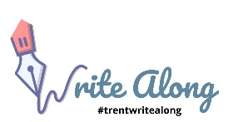 Creating an Outline

- Goal or purpose
  - Argument
  - Assessment
  - Explanation
- Question and thesis
- Blocks of essay: Categories or supporting ideas
  - Categories or Themes
  - Process or Stages
  - Chronological Narrative
  - Cause and effect
  - Background information
- Order the blocks
- Break down the blocks – different ideas to develop? What evidence? What connections?

Introduction
Topic – Purpose

Key Concepts/Ideas

Thesis

Background/Context

Block 1: Big Idea/Argument
Link to thesis

Block 1: Idea 1
What is the idea?

What evidence supports it?

How does it connect to the block?

Block 1: Idea 2
What is the idea?

What evidence supports it?

How does it connect to the block?

Block 1: Conclusion/Transition
Connect Idea 1 & Idea 2
Link to thesis

Block 2: Big Idea/Argument
Link to thesis

Block 2: Idea 1
What is the idea?

What evidence supports it?

How does it connect to the block?

Block 2: Idea 2
What is the idea?

What evidence supports it?

How does it connect to the block?

Block 2: Conclusion/Transition
Connect Idea 1 & Idea 2

Link to thesis

